背景
- 早期识别脑卒中对于及时治疗至关重要。
- 目前常用的评分系统和预测方法在不同患者群体中的表现存在差异。
- 单一模型可能难以充分反映不同患者之间的异质性。
- 因此，我们探索一种基于分组的建模方法，评估其是否能够改善预测性能。
方法
- 本研究使用既往临床数据预测患者是否发生脑卒中。
- 数据被划分为训练集和独立测试集。
- 我们首先基于样本特征进行分组，以识别潜在的患者子群体。
- 对于较易区分的样本，建立一套预测模型；
- 对于较难区分的样本，建立另一套模型。
- 测试样本根据其特征被分配至相应模型进行预测。
- 最终结果与使用全部训练数据建立的单一模型进行比较。
- 所有性能指标均在独立测试集上评估。
结果
- 在独立测试集中，Cohort-Routed 模型的 AUC 从 0.865 提升至 0.894。
- 在固定阈值 0.50 下，漏诊的脑卒中病例由 8 例减少至 4 例。
- 同时，正确识别的脑卒中病例由 105 例增加至 109 例。
- 假阳性仅增加 1 例。
- 整体敏感性提高，特异性略有下降但总体保持稳定。

Background
- Early identification of stroke is critical for timely treatment.
- Existing scoring systems and prediction methods may perform differently across patient groups.
- A single model may not fully capture the heterogeneity among patients.
- We therefore explored a subgroup-based modeling strategy to evaluate whether it could improve predictive performance.
Methods
- We used retrospective clinical data to predict stroke status.
- The dataset was divided into a training set and an independent test set.
- Samples were first grouped based on their features to identify potential patient subgroups.
- One predictive model was trained for relatively easier-to-separate cases,
and another model was trained for more difficult cases.
- Test samples were assigned to the appropriate model based on their feature-defined group.
- Final performance was compared with a single model trained on all training data.
- All metrics were evaluated on the independent test set.
Results
- On the independent test set, the cohort-routed model improved AUC from 0.865 to 0.894.
- At a fixed threshold of 0.50, the number of missed stroke cases decreased from 8 to 4.
- Correctly identified stroke cases increased from 105 to 109.
- False positives increased by one case.
- Overall sensitivity improved, while specificity showed a slight decrease but remained stable.

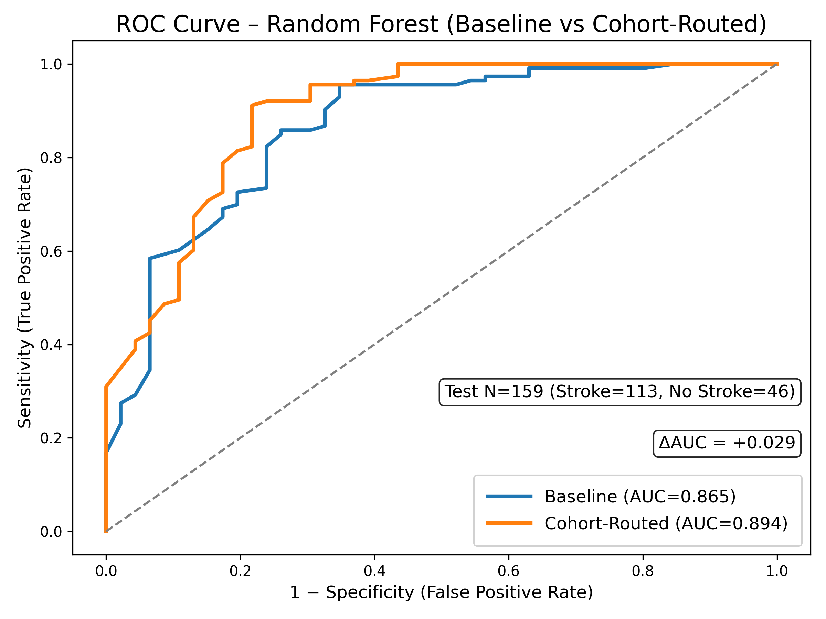
Figure 1. ROC comparison between baseline Random Forest and the cohort-routed strategy (proof-of-concept).
Both models were evaluated on the same independent test set (N = 159). The cohort-routed strategy achieved an AUC of 0.894 compared with 0.865 for the baseline model (AUC difference = +0.029). This represents a proof-of-concept evaluation on the current stroke dataset.
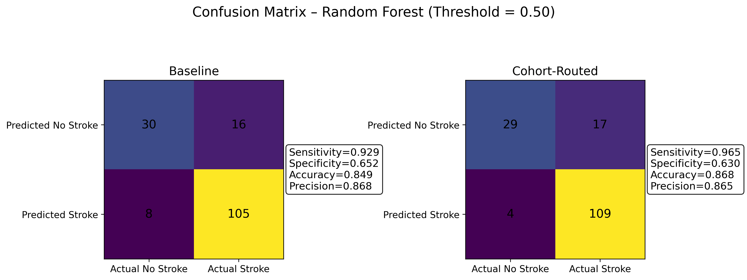
Figure 2. Confusion matrices of baseline and cohort-routed models at threshold = 0.50.
At a fixed decision threshold of 0.50, the cohort-routed model reduced missed stroke cases from 8 to 4 and increased correctly identified stroke cases from 105 to 109, with one additional false positive. Sensitivity improved, while specificity showed a slight decrease. Results are reported on the independent test set.

